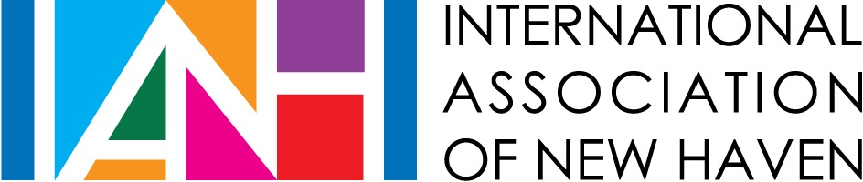
SPONSORSHIP REQUEST FORM

Sponsorship requests are limited to one per calendar year per organization, up to $1000.

APPLICANT INFORMATION

Name of Organization: _________________________________________________________________________

Street Address: _______________________________________________________________________________

City/State/Zip: ________________________________________________________________________________

Telephone: _______________________Website: ________ ____________________________________________

Application Contact Person: ____________________________________Title: _________________________

Contact Person Telephone: ___________________________Email: __________________________________

Executive Director: __________________________________Telephone: ___________________________

Federal Employer ID# ________________________________Date of Incorporation in CT: ________________

PLEASE COMPLETE:
- State your organization’s mission:

- Sponsorship Request Amount: __________

- Have you received an IANH sponsorship in the past? No Yes

  - If yes, what year: ______ How much: ______

- Briefly describe your request. Include the nature of the program or event for which you seek support and the number of people to be served or engaged. Please attach a program or event budget to this form.

Should the sponsorship be approved, the International Association of New Haven (IANH) requests to be credited in all print and online publicity for the program or event. Please follow us on Facebook and tag us on photos of your event(s). The IANH logo is available upon request for this purpose.

AUTHORIZATION
The undersigned certifies that they are authorized to represent the organization applying for a sponsorship grant and that the information contained in this application is accurate. The undersigned agrees that if a grant is awarded to the organization: (1) the sponsorship funds will be used for the purpose described in this application and may not be expended for any other purpose without prior written approval from the International Association of New Haven, (2) The International Association of New Haven has received nothing of material value in exchange for the grant, and (3) information about the organization and the sponsorship may be used by the International Association of New Haven any published materials.

Signature of Executive Director or Board Chairperson Date

